TOWN 04
Enable Lane Change Between Adjacent Lanelets

These are the steps to Enable Lane Change Between Adjacent Lanelets:
- Merge adjacent lanelets:
There are 2 lanelet very close to see it we can move the dot:
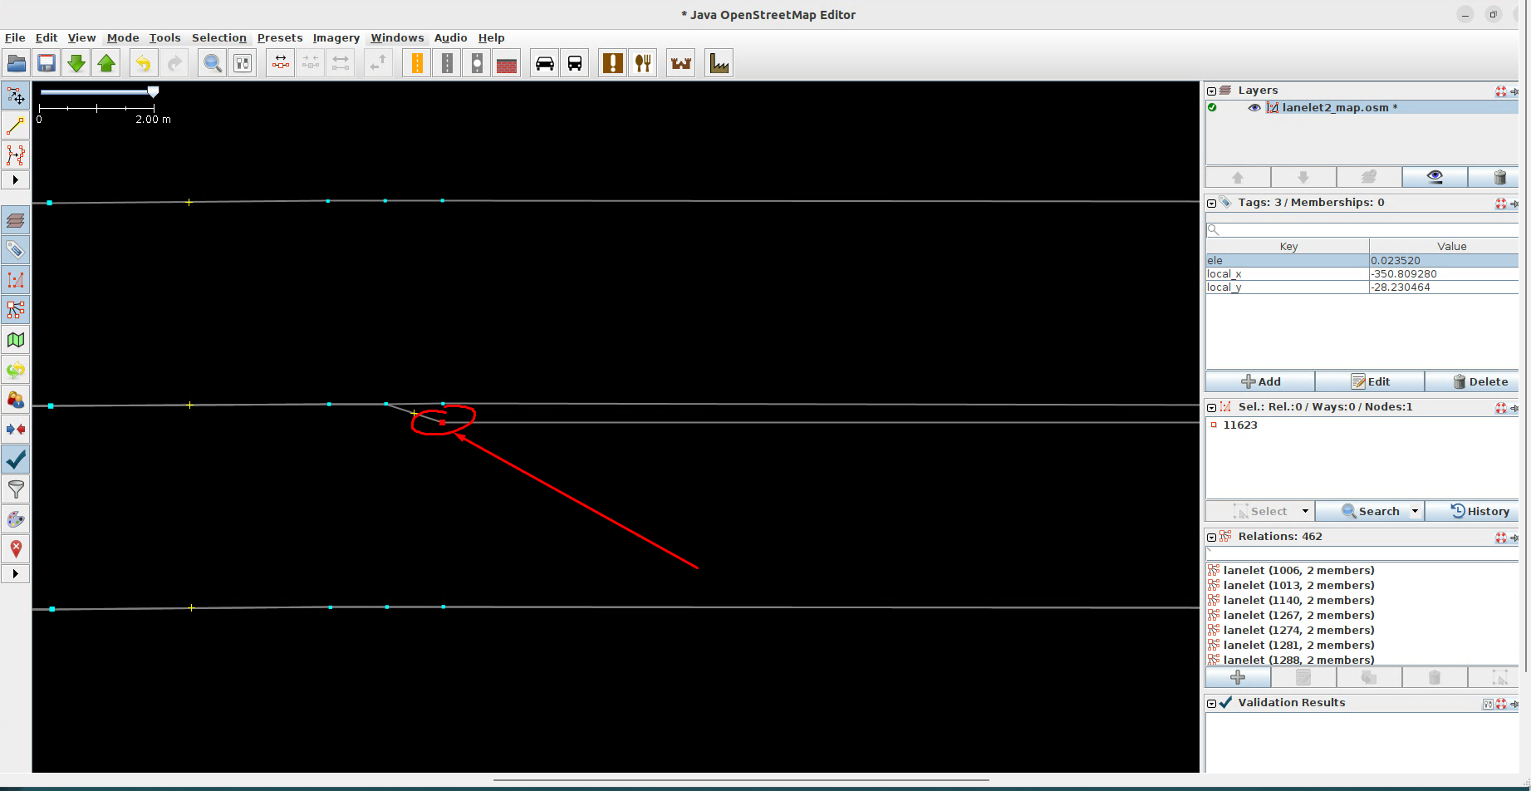
Select both:
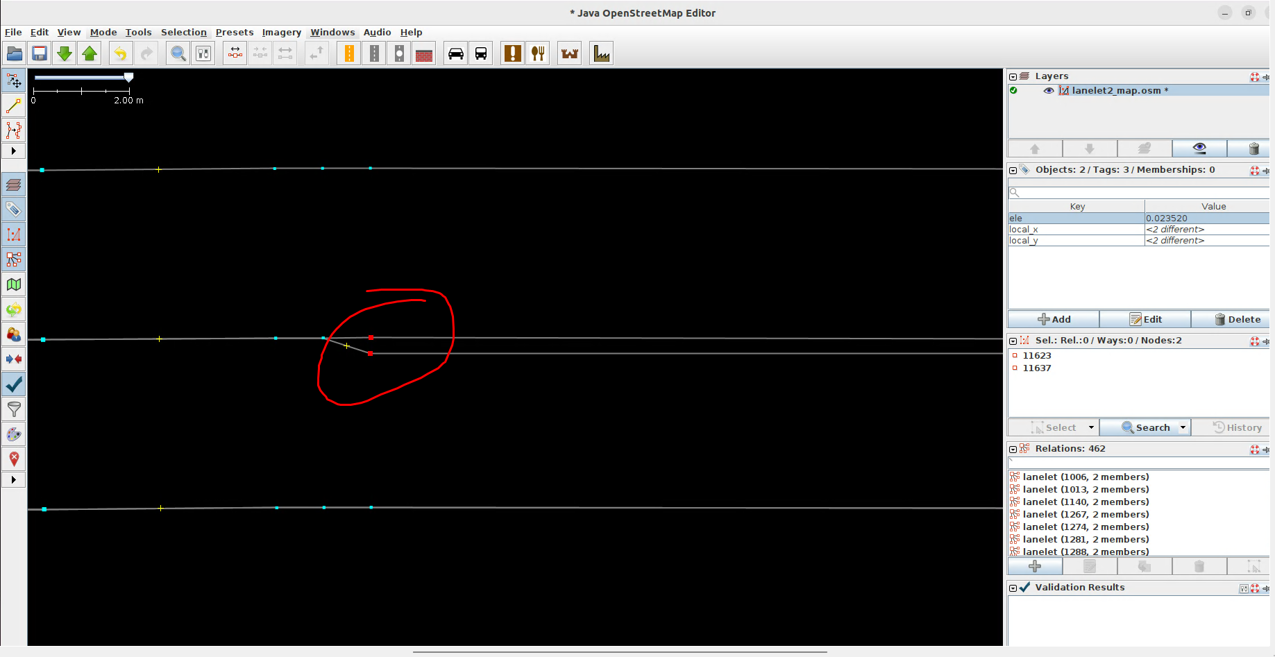
Press 'm' to merge the lanelets. Repeat the process at the other end.
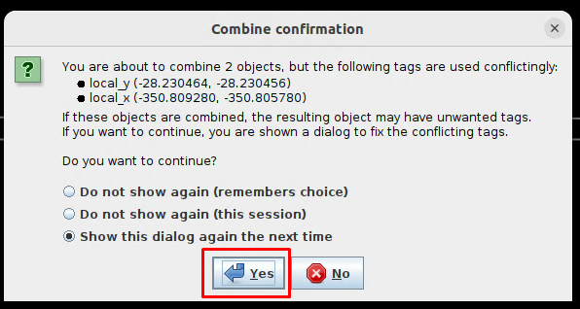
Select the upper one
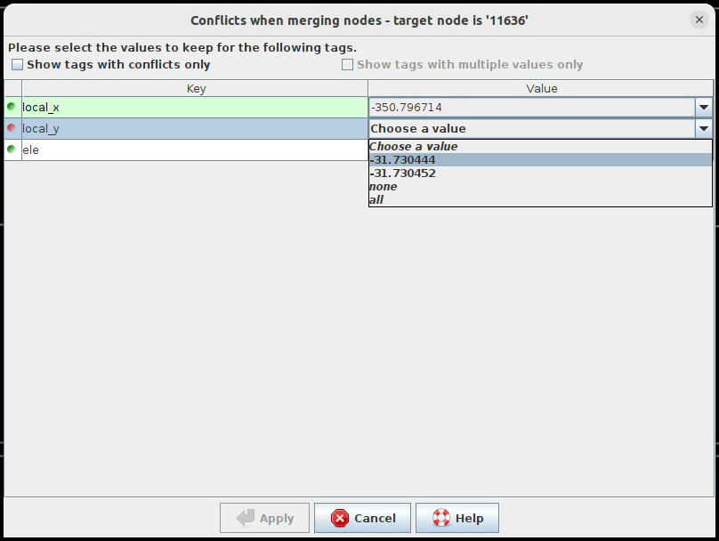
Even after merging, each lanelet still keeps its own left and right way.

- Unify the shared border:
Select one lanelet and replace its left way with the right way of the adjacent lanelet on its left — so both share the same border.
First select the way 11615. It is the right way of the lanelet 11627.
Second select the lanelet 11640, will have his left way 11615.
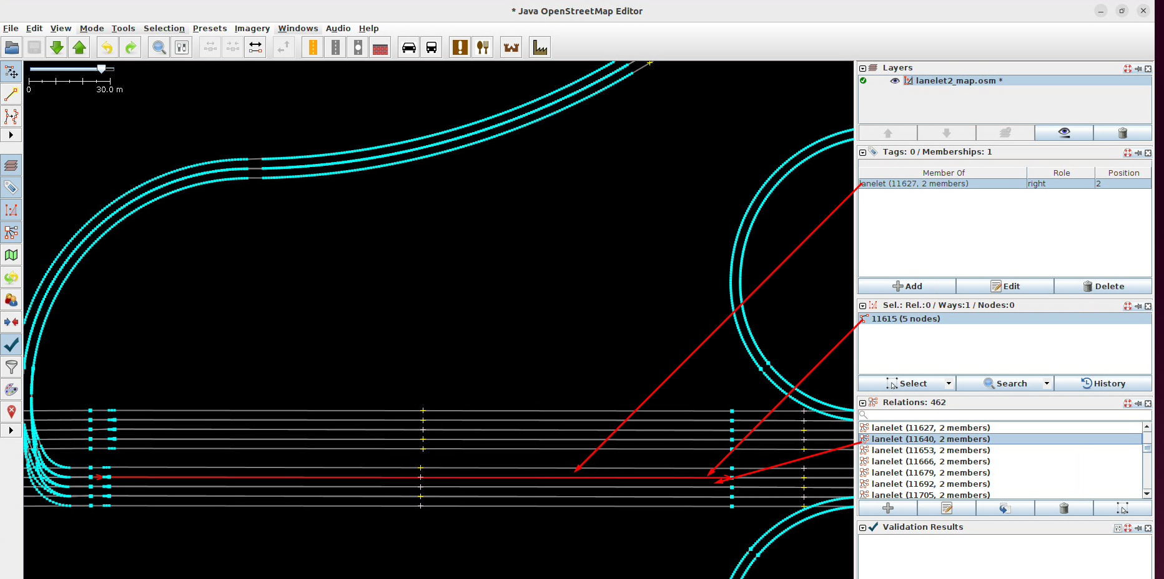
Edit the lanelet 11640:
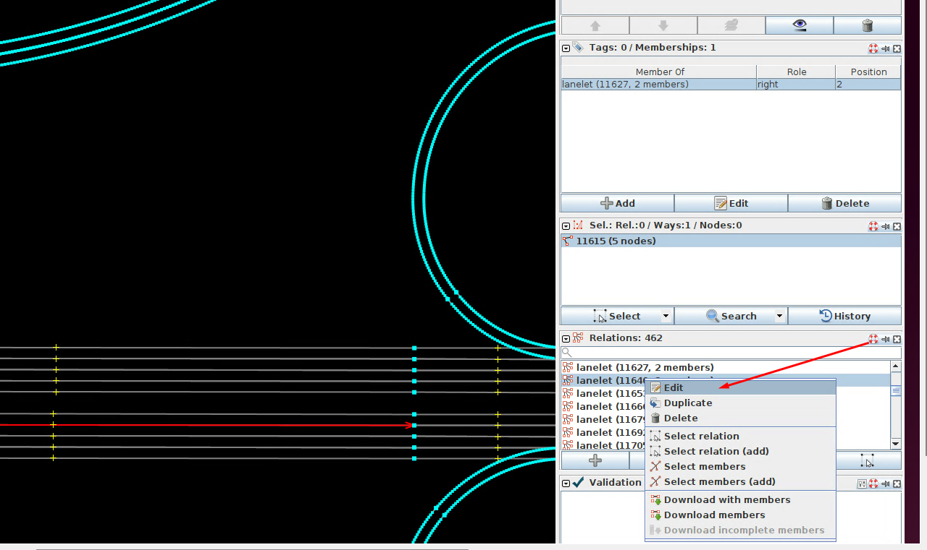
Delete the left way:
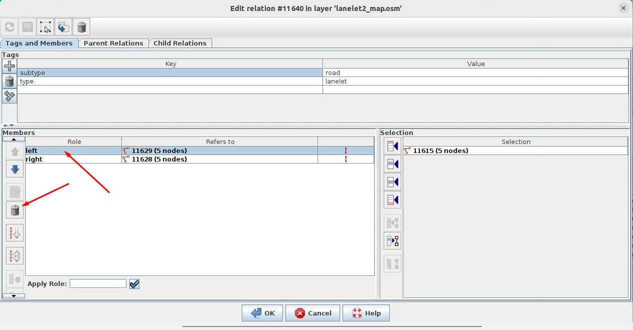
Add the new left:
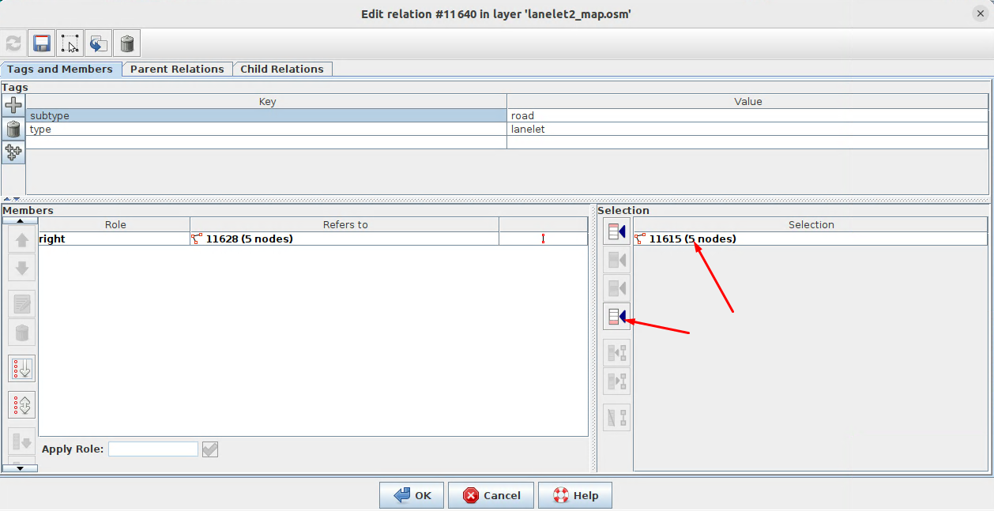
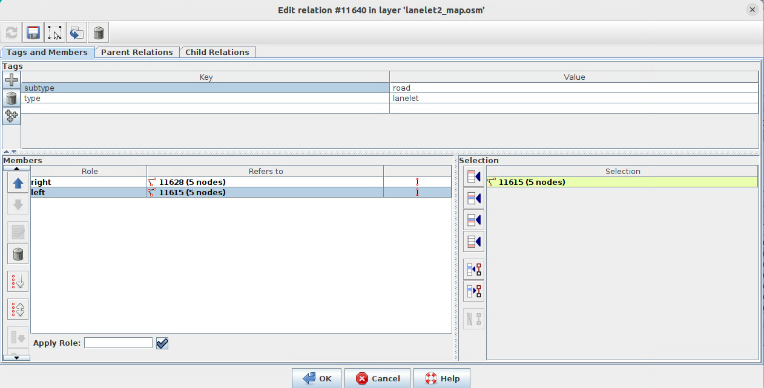
- Tag the shared way
Select the shared way and set the following tags:
  - type = line_thin
  - subtype = dashed
Select the way (it has 2 lanelets):
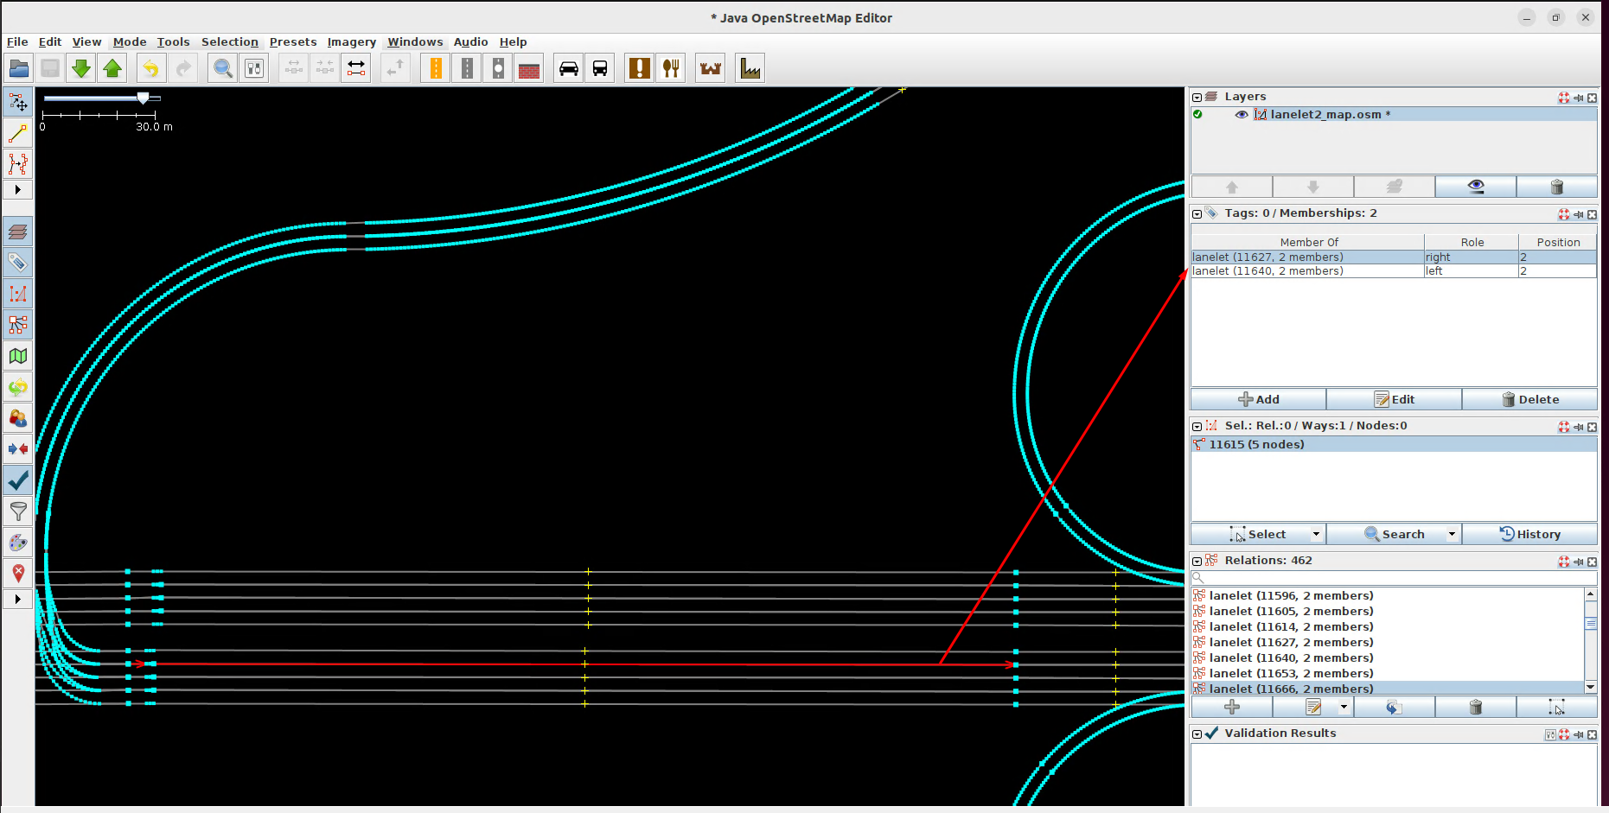
Add 2 tags:
